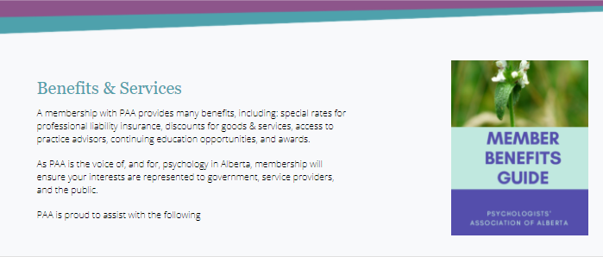

PAA 2022 Membership Survey
MEMBERS’ VIEWS ON BENEFITS
Annika Rorem, Membership Officer | PAA | January 2023

Executive Summary
PAA has been the professional association for psychologists since 1996. At present, PAA has 3 539 members, 67% of eligible members of the College of Alberta Psychologists. PAA surveys our membership in December annually to communicate and explore member satisfaction and needs to further refine our services and benefits. This 2022 membership survey had a 9% response rate with 314 members. Key findings from the 18 questions (15 topics) on member benefits:
Value in Membership
- The vast majority (95%) were Satisfied with their PAA membership; 96% were likely to recommend PAA to a colleague and most (91%) rated the membership value from average to excellent

Member Service & Support
- The vast majority (94%) found PAA to be Responsive

- Most (86%) found PAA’s Communications engaging

- Most (83%) were familiar with PAA’s Member Recognition programs for students, educators, researchers, practitioners, supervisors and employers

Member Tailored Benefits
- The vast majority (99%) considered PAA’s Practice Advisor Program beneficial, but several comments highlighted they would like increased access to this program.

- The vast majority (94%) considered PAA’s Collaborate beneficial

- The vast majority (95%) are aware of PAA’s Continuing Professional Development activities; some comments supported advancements in CPD

- The vast majority (98%) considered PAA’s Ethics Round Tables beneficial

- The vast majority (91%) are likely to use PAA’s new Professional Guidance Program

- Many (58%) are likely to use Collaborate’s new Volunteer Program and upcoming Mentor Match programs to find new opportunities

- Many (78%) believe PAA’s Referral Service is impactful

- Awareness of, and use of, PAA Membership Incentives varied; most (97%) for the discounted liability + other insurances, most (71%) for the technology services from PAA’s affinity partners, some (59%) for other discounts; comments highlighted member appreciation for PAA member benefits

Advocacy
- The vast majority (94%) were satisfied with PAA’s work to advance our Professional Identity

- Most (80%) were familiar with PAA’s Advocacy Efforts; many comments supported this as an important factor of their membership

PAA requires strong membership to advance its objectives, fulfill its mission, and realize its strategic plan. Recommendations are made specific to the merit of repeating this survey yearly and using results in targeted program evaluation and refinement.
Introduction
Originally a joint organization with the profession’s regulatory body since 1958, in 1996 the Psychologists’ Association of Alberta (PAA) officially incorporated as a separate non-profit professional association from the College of Alberta Psychologists (CAP). At present, CAP has 4 604 members; PAA has 3 539. Membership in the PAA is voluntary and is the primary source of revenue for the organization. Members are key contributors in the PAA realizing its mission.
The Psychologists' Association of Alberta is the voice of, and for, psychology in Alberta. We are the voluntary body that advocates for psychology in Alberta, informs the public and the media, and advocates for consumers of psychotherapy, psychological, and mental health services. The Mission of the PAA is to advance the science-based profession of psychology and to promote the well-being and potential of all Albertans.
The goals of this survey were to:
- Communicate awareness about current and upcoming PAA member benefits
- Gather further information about the level of awareness members have about PAA services and programs, and membership satisfaction in general
- Investigate how much members utilize the membership benefits
This report serves as a guide to clarify key success and issues in membership, a growth plan related to the same, specific to PAA’s realization of the 2020 – 2025 Strategic Plan goals:

Advocate for psychology’s unique value

Promote the psychological health of all Albertans

Enhance the development of psychologists across career lifespan

Focus on PAA’s membership value

Ensure financial stability

2022 Membership Survey
Methodology
As part of the communications plan, specific to the evolving membership recruitment and retention plan, an online survey was designed with the dual intention of awareness and assessment of current PAA membership benefits.

The survey was kept brief, consistent with online survey recommendations, and Likert scales were the predominant assessment modality along with forced-choice and long answer responses.

There were 18 questions on 15 topics that targeted member benefits as advertised as PAA Member Benefits. Topics were:

1. Professional Identity
2. Advocacy
3. Communications
4. Membership Incentives
5. PAA Responsiveness
6. Continuing Professional Development
7. Membership Satisfaction
8. Member Recognition
9. Practice Advisors
10. Referral Service
11. Membership Value
12. Collaborate
13. Professional Guidance Program
14. Mentor Match Program
15. Ethics Round Tables

All 3 539 current members of PAA were invited (via email) to participate in the online survey over 2 weeks starting 06 December 2022.

Sample
There were 314 usable responses. That is a participation rate of 9%; 25% is considered significant in online population surveys. Although this could not be considered representative of the membership, the results are relevant to ongoing engagement.

Discussion
This survey was sufficiently similar to the 2021 PAA Membership Survey to allow for comparability of results.
There were 4 new topics added to the 2022 survey about new and upcoming PAA services that were not featured on previous surveys. The data on Collaborate, Professional Guidance Program, Mentor Match Program, and Ethics Round Tables cannot be compared to the 2021 PAA Membership Survey.
Consistent Findings
Many responses on the 2022 Membership Survey varied by less than 4% from the 2021 Membership survey.
- PAA Practice Advisor Program
- PAA’s Advocacy Efforts
- PAA Responsiveness
- Membership Value
- Professional Identity
- PAA Communications
- Referral Service

Statistically Significant Increase
The most encouraging increase was observed in the impact of the level of awareness in the PAA Membership Incentives which was higher in every category.
Statistically, a significant increase was found in the levels of awareness for the PAA Membership Incentives from 2021-2022*.
- The discounted liability and other insurances saw an increase in reported awareness (8%).
- The other membership discounts saw the highest increase in reported awareness (33-49%)

Discussion
Steady or increasing results indicate consistent levels of member satisfaction. This also provides a baseline for future services added, the impact of staffing increases, and improvements to our web presence and referral service.

* 95% confidence level was used to calculate statistical significance in the differences of the data from 2021 to 2022.

