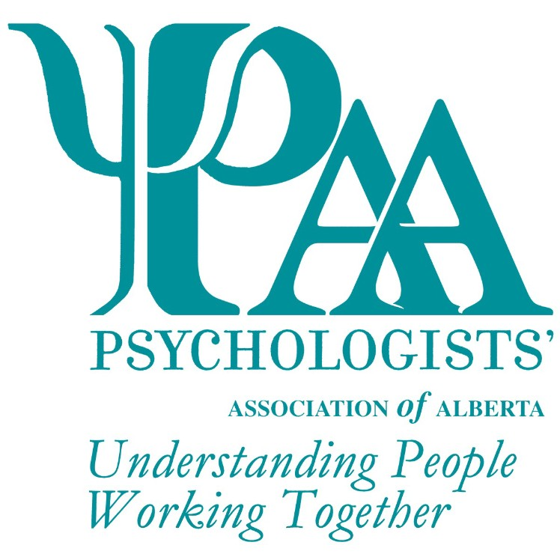
Psychologists' Association of Alberta
101, 1259-91 Street SW
Edmonton, AB T6X 1E9
T: 780-424-0294 TF: 1-888-424-0297
F: 780-423-4048
W: www.psychologistsassociation.ab.ca E: paa@paa-ab.ca
Doctoral Dissertation Research Award Form
The Psychologists' Association of Alberta (PAA) invites members* who are doctoral level students to complete this form and all required documents and submit for nomination. This is a monetary award ($300.00), together with a complimentary ticket to the PAA Awards Banquet.
The PAA Awards Committee will review all nominations and select the recipient based on originality, clarity, and the following criteria (not necessarily exhaustive):

Title of Dissertation
Research
Explain how the dissertation is based on current research (has been completed and defended during the two years immediately preceding award submission date) (max 250 words):

Explain how the research is of high quality in terms of purpose, approach, methodology, and implications (max 200 words):

Explain how this dissertation research has the potential to contribute to the field of psychology (max 250 words):

Submissions must be accompanied by:
- An abstract of the dissertation.
- Two letters of support, one from a supervisor and one from a dissertation committee member, stating that the majority of the work and thought has been completed by the student.

Nominee Information

Title Name

Phone Address City Prov Postal Code

Email Signature**

Checklist for Application:
Doctoral Dissertation Research Award Form Supervisor Letter of Support
Dissertation Committee Member Letter of Support

Abstract

PAA Awards are given every year. Deadline date for the next award nominations: 30 April 2022.
This form may be submitted via e-mail, fax, or mail. Additional information, if required, can be included but is limited to 2 pages.
*This award is available to all student, provisional, ECP, and full members of PAA. If you are not a member, please visit our website for information and to apply.
**Your signature indicates agreement to be nominated and for PAA to use your name for marketing purposes

