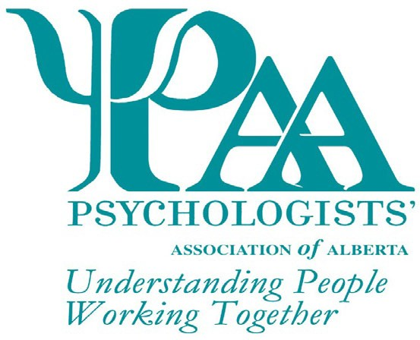
Psychologists' Association of Alberta
101, 1259-91 Street SW
Edmonton, AB T6X 1E9
T: 780-424-0294 TF: 1-888-424-0297
F: 780-423-4048
W: www.psychologistsassociation.ab.ca E: paa@paa-ab.ca

Nomination for the Excellence in Clinical Supervision Award
The Psychologists' Association of Alberta (PAA) invites nominations for the Excellence in Clinical Supervision Award. This non-monetary award is presented to an individual whose performance in supervising one or more individuals in any practice area is deemed exemplary during the previous two-year period.

This award is available to members and non-members of PAA who are registered psychologists.
Nominators may or may not be PAA members. The nominator may be professional colleagues, former/current students or supervisees of the nominee, or individuals familiar with the nominees practice.

The PAA Awards Committee will review all nominations and select the recipient for the award based on the following criteria, not necessarily exhaustive:

Explain the nominee's availability for consultation, training, and emergencies (max 250 words):

Explain the nominee's ability to align with supervisees needs and personal approach (max 250 words):

Explain the nominee's ability to offer diverse and appropriate options for various assessments/treatment/ethical situations (max 250 words):

Explain the nominee's knowledge in terms of psychological theory, techniques, approaches, and practical suggestions (max 250 words):

Explain the nominee's ability to provide creative/flexible approaches to delivery of supervision (max 250 words):

Explain the nominee's ability to provide constructive feedback that is related to both corrective/critical appraisal, and validation of good student practice (max 250 words):

Please explain the specific criteria used to nominate this individual, the approximate number of hours devoted to supervising, and methods of supervision employed (max 250 words):

Nominee Information

Title Name Phone

Address City Prov Postal Code Email Signature*
*Your signature indicates agreement to be nominated and for PAA to use your name for marketing purposes

Nominator Information

Title Name Phone

Address City Prov Postal Code Email

This form may be submitted via e-mail, fax, or mail. Additional information, if required, can be included but is limited to 2 pages.

Checklist for Application
Excellence in Clinical Supervision Award Form

PAA Awards are given every year. Deadline date for the next award nominations: 30 April 2022

Nominations for individuals not selected as the recipient of the award may be carried forward for consideration by the committee for two years following initial nomination. Recipients of this award may be nominated again for this award in the future; however, a period of three
(3) years must have passed before they are eligible for re-nomination. All applicants will receive notification of the outcome of their submission.

