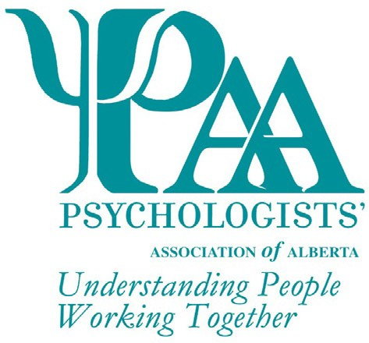
Psychologists' Association of Alberta
101, 1259-91 Street SW
Edmonton, AB T6X 1E9
T: 780-424-0294 TF: 1-888-424-0297
F: 780-423-4048
W: www.psychologistsassociation.ab.ca E: paa@paa-ab.ca

Nomination for the Excellence in Teaching Psychology Award
The Psychologists' Association of Alberta (PAA) invites nominations for the Excellence in Teaching Psychology Award. This non-monetary award is presented to an individual who demonstrates "outstanding" teaching of psychology in an Alberta Government approved/authorized institution for post-secondary education.
This award is available to members and non-members of PAA. Nominators may or may not be PAA members.
The nominator may be teaching and/or professional colleagues, former or current students, supervisors, or other individuals familiar with the nominee's teaching. Additional signatories would strengthen the nominations.

The PAA Awards Committee will review all nominations and select the recipient for the award based on the following criteria (not necessarily exhaustive):
Explain how the nominee has taught for a minimum of two years immediately preceding the award, one year of which may have been a sabbatical (max 250 words):

Explain how the nominee's teaching could be deemed "outstanding", as manifested through any combination of the following:
Educational methodology

Enthusiasm

Commitment to the subject of psychology

Commitment & dedication to the students

Teaching innovation

Supervision of scholarly research

PAA Awards are given every year. Deadline date for the next award nominations: 30 April 2022

Explain any additional criteria you used to nominate this individual (max 500 words):

Nominee Information

Title Name Phone

Address City Prov Postal Code Email Signature*
*Your signature indicates agreement to be nominated and for PAA to use your name for marketing purposes

Nominator Information

Title Name Phone

Address City Prov Postal Code Email
This form may be submitted via e-mail, fax, or mail. Additional information, if required, can be included but is limited to 2 pages.

Checklist for Application
Excellence in Teaching Psychology Award Form

PAA Awards are given every year. Deadline date for the next award nominations: 30 April 2022
Nominations for individuals not selected as the recipient of the award may be carried forward for consideration by the committee for two years following the initial nomination. Recipients of this award may be nominated again for this award in the future; however, a period of three (3) years must have passed before they are eligible for re-nomination. All applications will receive notification of the outcome of their submission.

