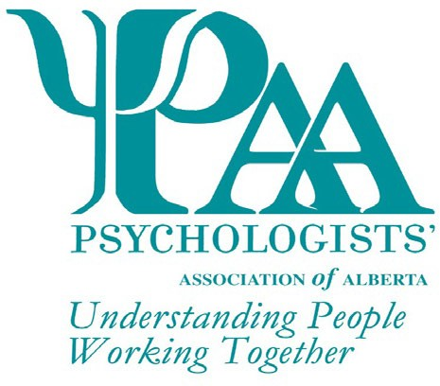
Psychologists' Association of Alberta
101, 1259-91 Street SW
Edmonton, AB T6X 1E9
T: 780-424-0294 TF: 1-888-424-0297
F: 780-423-4048
W: www.psychologistsassociation.ab.ca E: paa@paa-ab.ca

Nomination for the Juanita Chambers Excellence in Community Service Award
The Psychologists' Association of Alberta (PAA) invites nominations* for the Juanita Chambers Excellence in Community Service Award. This non-monetary award is presented to an individual in recognition of important work in advancing psychological health, well-being, and quality of life for Albertans through service to the community or advocacy.

The PAA Awards Committee will review all nominations and select the recipient for the award based on the following criteria (not necessarily exhaustive):
Explain how the nominee contributes to the quality of life in the community through volunteer work (max 250 words):

Explain how the nominee advocates for improved quality of life for Albertans (max 250 words):

Explain how the nominee educates the community about the value of psychological health, advocates for those in the community that need support and/or community resources to improve their quality of life (max 250 words):

PAA Awards are given every year. Deadline date for the next award nominations: 30 April 2022
*A PAA member is required to nominate an individual for this award. This award is available to an individual who may or may not be a psychologist or a PAA member.

Explain how the nominee is a positive role model for others (max 250 words):

Explain how the nominee contributes to the psychological health and well being of the community (max 250 words):

Explain how the nominee contributes to enhancing the public perception of psychologists through community service (max 250 words):

Explain how the nominee promotes social justice issues (max 250 words):

PAA Awards are given every year. Deadline date for the next award nominations: 30 April 202
*A PAA member is required to nominate an individual for this award. This award is available to an individual who may or may not be a psychologist or a PAA member.

Outline any additional criteria, specific to the nominee's area of outstanding service, including specific accomplishments (max 500 words)

Nominee Information

Title Name Phone

Address City Prov Postal Code Email Signature*
*Your signature indicates agreement to be nominated and for PAA to use your name for marketing purposes

Nominator Information

Title Name Phone

Address City Prov Postal Code Email
This form may be submitted via e-mail, fax, or mail. Additional information, if required, can be included but is limited to 2 pages.

Checklist for Application
Excellence in Community Service Award Form

PAA Awards are given every year. Deadline date for the next award nominations: 30 April 2022
Nominations for individuals not selected as the recipient of the award may be carried forward for consideration by the committee for two years following initial nomination. Recipients of this award may be nominated again for this award in the future; however, a period of three
(3) years must have passed before they are eligible for re-nomination. All applications will receive notification of the outcome of their submission.

