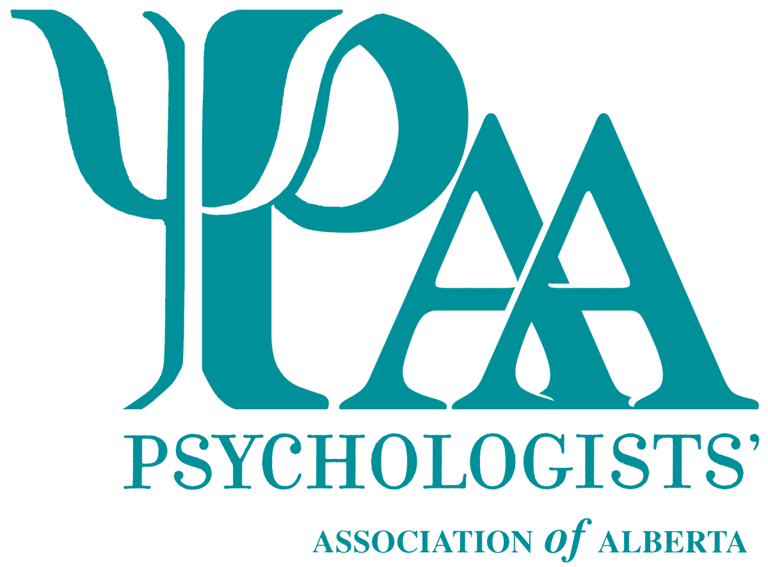**Online psychological treatment to prevent spread of COVID-19**

Currently, the risk level in Alberta is low for COVID-19. We can continue to provide treatment for you in person if you are feeling healthy.

We can also arrange for your sessions to be completed online using a video psychological treatment platform called doxy.me.

**We ask you to request sessions via online psychological treatment if you have symptoms such as:**

* Cough
* Fever
* Any signs of a cold or flu

**Please inform us and we will arrange online sessions if you have:**

* Travelled on a Grand Princess Cruise, to Iran or to China’s Hubei province in the last 14 days.
* Had contact with someone who was suspected or confirmed to have coronavirus.
* Travelled anywhere and were in a health care facility.

If you are unsure as to whether you should come in or not, it’s best to be cautious, stay home and do online psychological treatment.

We will inform you if there is a need to move all clients to an online psychological treatment option.

Our goals are to help everyone stay healthy and safe and for our clients to continue to receive uninterrupted psychological treatment.

Please call <phone number> or email <e-mail address> to arrange for online psychological treatment or if you have any questions or concerns.

Yours truly,