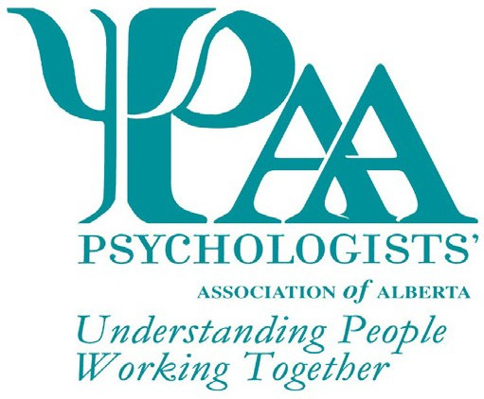
Psychologists' Association of Alberta
101, 1259-91 Street SW
Edmonton, AB T6X 1E9
T: 780-424-0294
W:www.psychologistsassociation.ab.ca E: paa@paa-ab.ca

Nomination for the John G. Paterson Media Award
The Psychologists' Association of Alberta (PAA) invites nominations for the John G. Paterson Media Award. This non-monetary award is presented to an individual in recognition of significant media contributions that have advanced the public knowledge and profession of psychology during the previous two-year period.
Explain how the nominee has exceptionally contributed to portraying psychological knowledge to the public (max 250 words)

Explain how the nominee has furthered the advancement of the profession of psychology with the public through their contribution (max 250 words)

Explain how the nominee has conveyed psychological knowledge through the media of radio, television, print, or electronic communication. Select all that apply. (Max 250 words)
Radio Television Print Electronic Communication

PAA Awards are given every year. Deadline date for the next award nominations: 30 April 2023

Nominee Information

Title Name Phone

Address City Prov Postal Code Email Signature*
*Your signature indicates agreement to be nominated and for PAA to use your name for marketing purposes

Nominator Information

Title Name Phone

Address City Prov Postal Code Email

Checklist for Application
John G Paterson Media Award Form

PAA Awards are given every year. Deadline date for the next award nominations: 30 April 2023 Nominations for individuals not selected as the recipient of the award may be carried forward for consideration by the committee for two years following the initial nomination. Recipients of this award may be nominated again for this award in the future, after a period of three (3) years has passed. All applications will receive notification of the outcome of their submission

