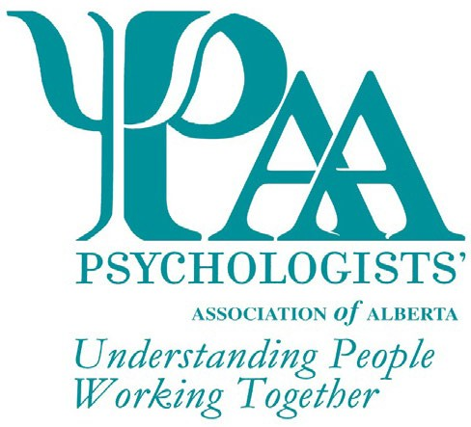
Psychologists' Association of Alberta
101, 1259-91 Street SW
Edmonton, AB T6X 1E9
T: 780-424-0294
W: www.paa-ab.ca
E: paa@paa-ab.ca

Nomination for the Psychologist of the Year Award
The Psychologists' Association of Alberta (PAA) invites nominations* for the Psychologist of the Year Award. This non-monetary award is presented to an individual to acknowledge significant achievement or contribution in the field of psychology during the previous two-year period.

The PAA Awards Committee will review all nominations and select the recipient for the award based on the following criteria (not necessarily exhaustive):
Explain how the nominee exhibits excellence in the practice of psychology (e.g. clinical/service delivery, advocacy, research, etc). (max 250 words)

Explain how the nominee exhibits active promotion of the ethical principles of psychologists. (max 250 words)

Explain how the nominee exhibits active involvement and membership within local, provincial, and/or national psychology organizations (max 250 words)

Explain how the nominee advocates for the enhancement of the professional practice of psychology (max 250 words)

Explain how the nominee contributes to public welfare, and the awareness of psychology and mental health issues (max 250 words)

Explain how the nominee demonstrates professional responsibility, growth, and leadership within the profession (max 250 words)

Explain how the nominee has received local, provincial, and/or national recognition (max 250 words)

Nominations may be in the following categories (select all that apply):

Advocacy Clinical/Counselling School/Educational Research

Social

Industrial/Organizational
Developmental

Explain any additional particular criteria used to select the nominee (max 500 words)

PAA Awards are given every year. Deadline date for the next award nominations: 30 April 2023
*A PAA member is required to nominate a fellow PAA member for this award. If you are currently not a member of PAA, please visit our website for more information and to apply.

Nominee Information

Title Name Phone

Address City Prov Postal Code Email Signature*
*Your signature indicates agreement to be nominated and for PAA to use your name for marketing purposes

Nominator Information

Title Name Phone

Address City Prov Postal Code Email

Checklist for Application
This form may be submitted via e-mail or mail. Additional information, if required, can be included but is limited to 2 pages.
Psychologist of the Year Award Form

PAA Awards are given every year. Deadline date for the next award nominations: 30 April 2023

Nominations for individuals not selected as the recipient of the award may be carried forward for consideration by the committee for two years following initial nomination. Recipients of this award may be nominated again for this award in the future; however, a period of three
(3) years must have passed before they are eligible for re-nomination. All applications will receive notification of the outcome of their submission.

