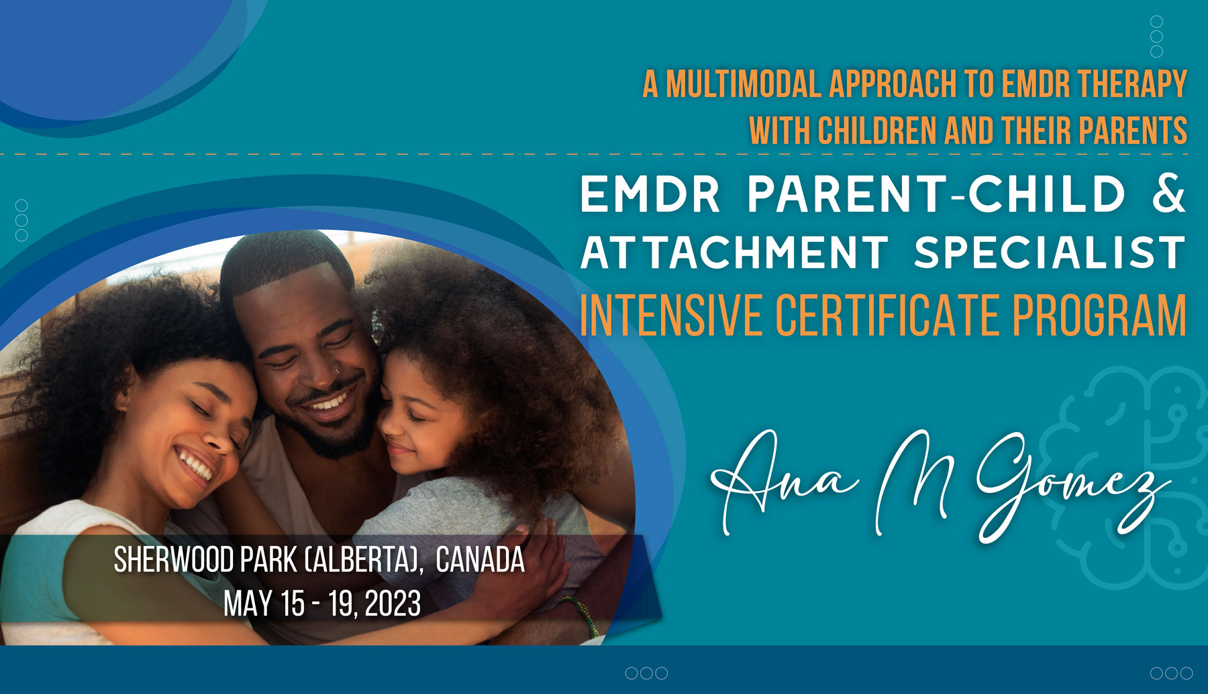

The Systemic, EMDR- Attachment Based Program to Heal Intergenerational Trauma & Repair the Parent-Child Attachment Bond”
Program includes:
9 hours of online training
36 hours of in person training
Cost: $1250 USD A total of 45 EMDRIA CEUs

https://agateinstitute.org/event/emdr-parent-child-attachment-specialist-intensive-certificate-program-alberta-canada/

